|  |
| --- |
| Gamindustri |
| Ghostly Maze |
| **Assignment 3 – Simple 3D Game** |
| Version 5.4.1f1 Personal  All work Copyright © 2016 by Gamindustri.  All rights reserved. |
| **Ronnel Ian Villarino** |
|  |



|  |
| --- |
| November 21, 2016 |

# Table of Contents

Contents

Table of Contents 2

Version History 3

Details 4

# Version History

Version 5.4.1f1 Personal – Current Version. No real changes to the game

# Details

1. **Game Overview**

The goal is to reach the end of the level while being able to avoid enemies.

1. **Game Play Mechanics**

The game is about a player as he/she navigates through the maze trying to find the exit. If there is time, they may be a way to fight back against the enemy if they chase the player.

1. **Camera**

The point of view is from the player’s perspective.

1. **Controls**

The keys used for the game is the WASD keys. The player can press the space bar to jump. Shift key to sprint. Left-click to shoot.

1. **Saving and Loading**

There is no saving or loading in this game.

1. **Interface Sketch**

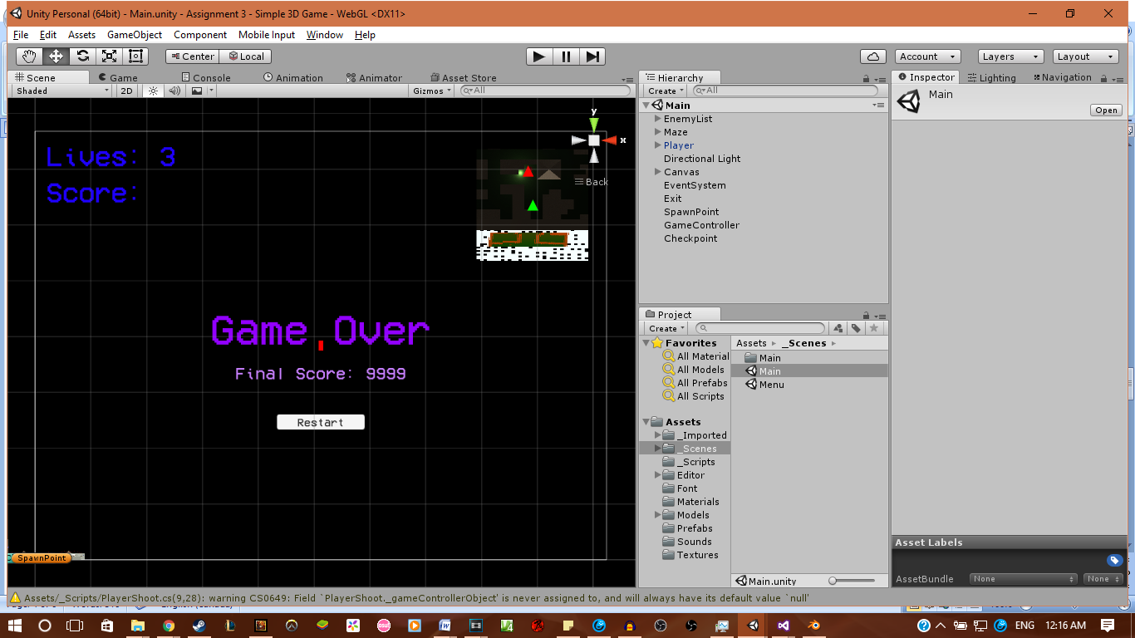

1. **Menu and Screen Descriptions**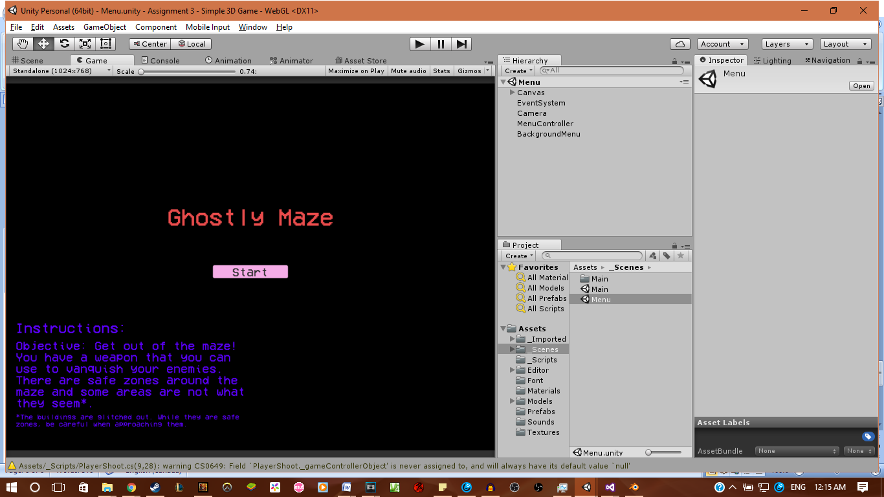

**This is the menu screen. It has a title and button in the middle, with instructions on the button left.**

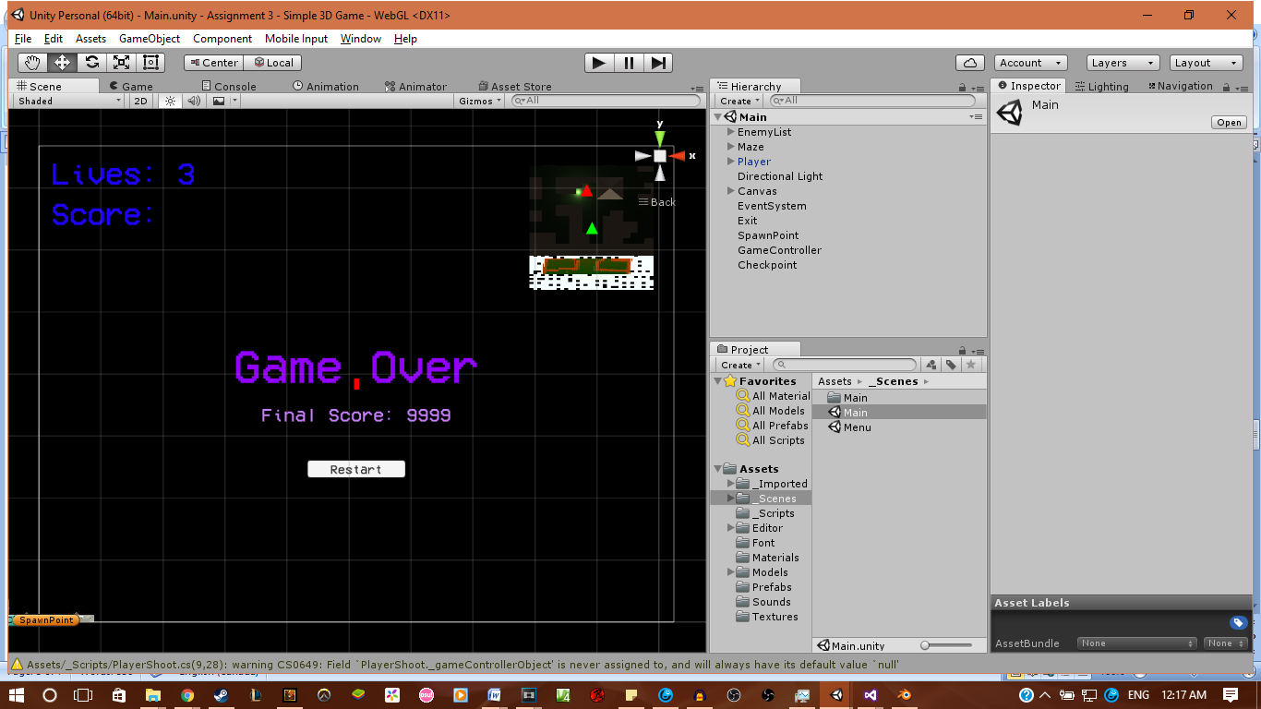

**This is the interface in-game. Lives and score on the top right, with the minimap on the top left. The Game Over, Final Score, and Restart button only appear when the player is dead.**

1. **Game World**

The game world can be described with a plane of grass with white (not pure white) walls and a tiled-like roof if the player was ever able to see it. There are also crossroads in the maze and a house (although glitched).

1. **Level**

There is only one level where the player has to traverse the maze to find the exit.

1. **Game Progression**

There is no game progression. The player only has to reach the end for the game to be done.

1. **Character**

There is only one player character now, which cannot be seen. It can be assumed to be a human.

1. **Enemies**

The enemy can be described as a red ghost. Some of them just stand still while others are aware of the player’s presence and will try to catch them.

1. **Weapons**

There is a weapon called “Crescent Rose”. It is in scythe form but is still able to shoot bullets, effectively giving the player a way to defend him/herself.

1. **Items**

There are no in-game items.

1. **Script**

There are several scripts. One script is what happens when the player shoots. Another is for checkpoint and spawn points. A third script is for the enemies on what they can do. And the last is the menu controller for when the player is dead.

1. **Scoring**

There is a scoring system. For every time, the player destroys a ghost; he/she will be awarded 100 points.

1. **Puzzles/Mini-games**

The only thing that can be considered a puzzle is being able to recognize where you are in the maze to be able to find the exit.

1. **Bonuses**

No bonuses.

1. **Cheat Codes**

No cheats. You need to use your skill and awareness to complete this.

1. **Sound Index**

There are several sounds. One of it is for when the player destroys a ghost. Another is for player movement. A third sound is for when the weapon shoots. And the last audio is a song that is played in the Menu.

1. **Story Index**

The story can be said that the player just woke up suddenly in this place and has to try to survive and find the exit to find out what is happening.

1. **Art / Multimedia Index**

**Enemy:**

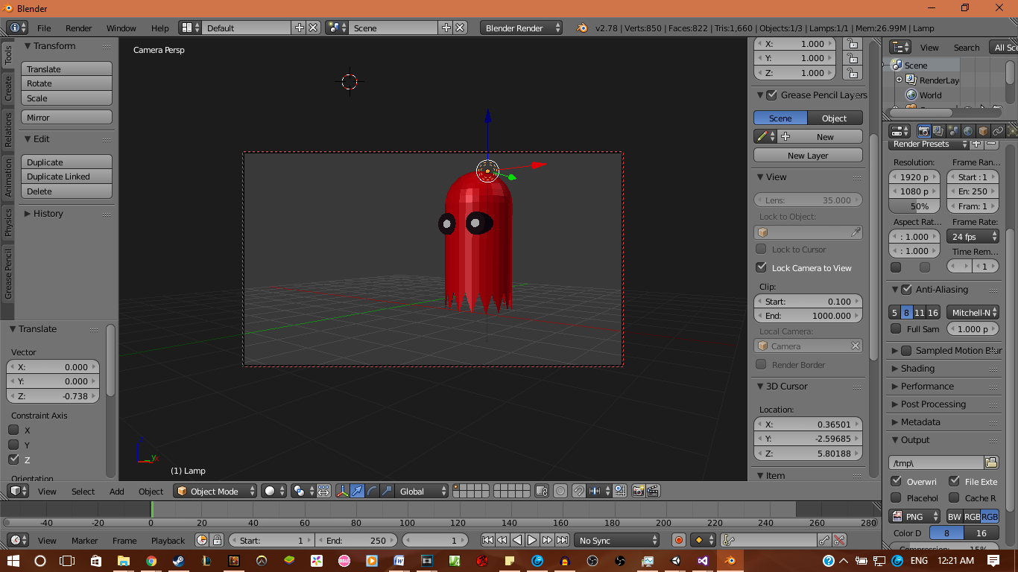

Weapon:

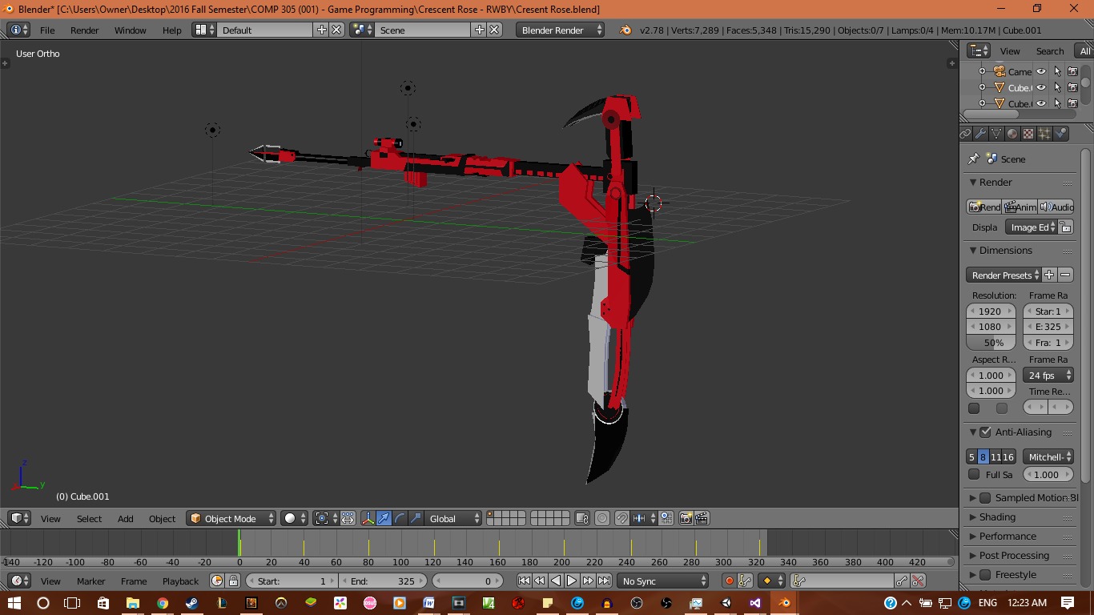

The Tiles for Maze:

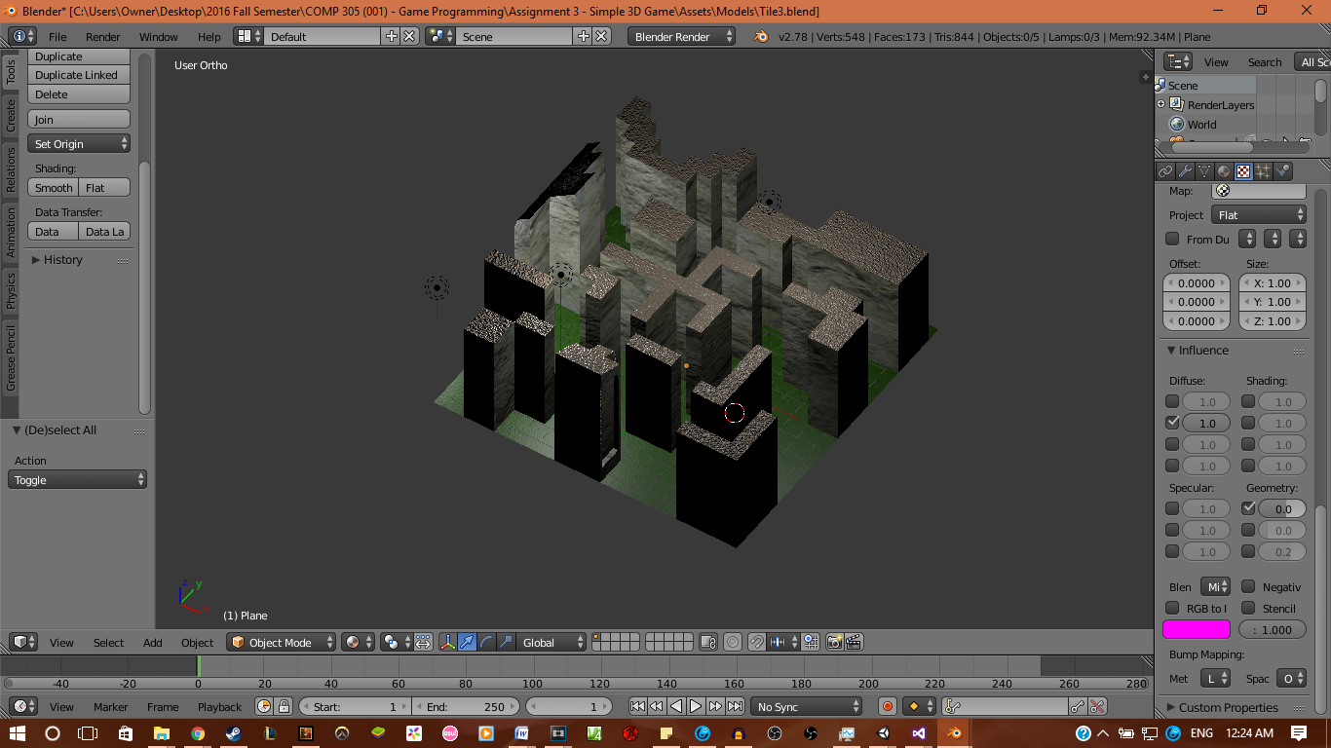

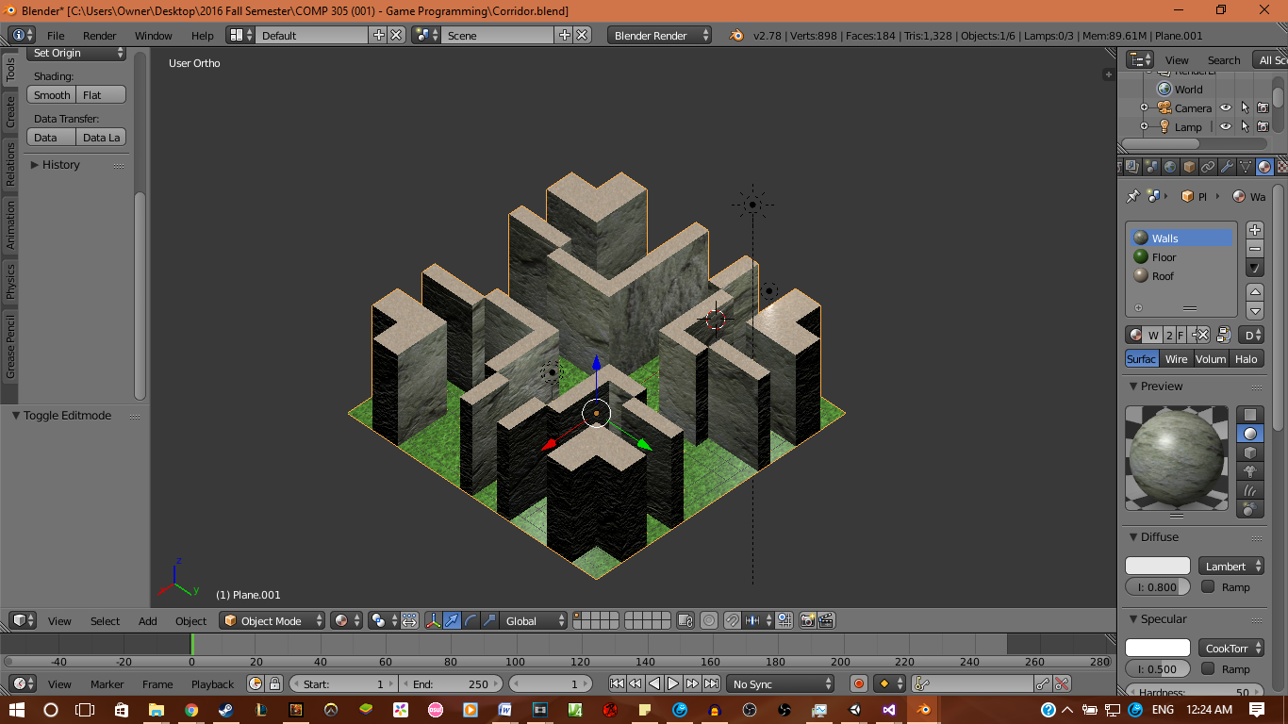

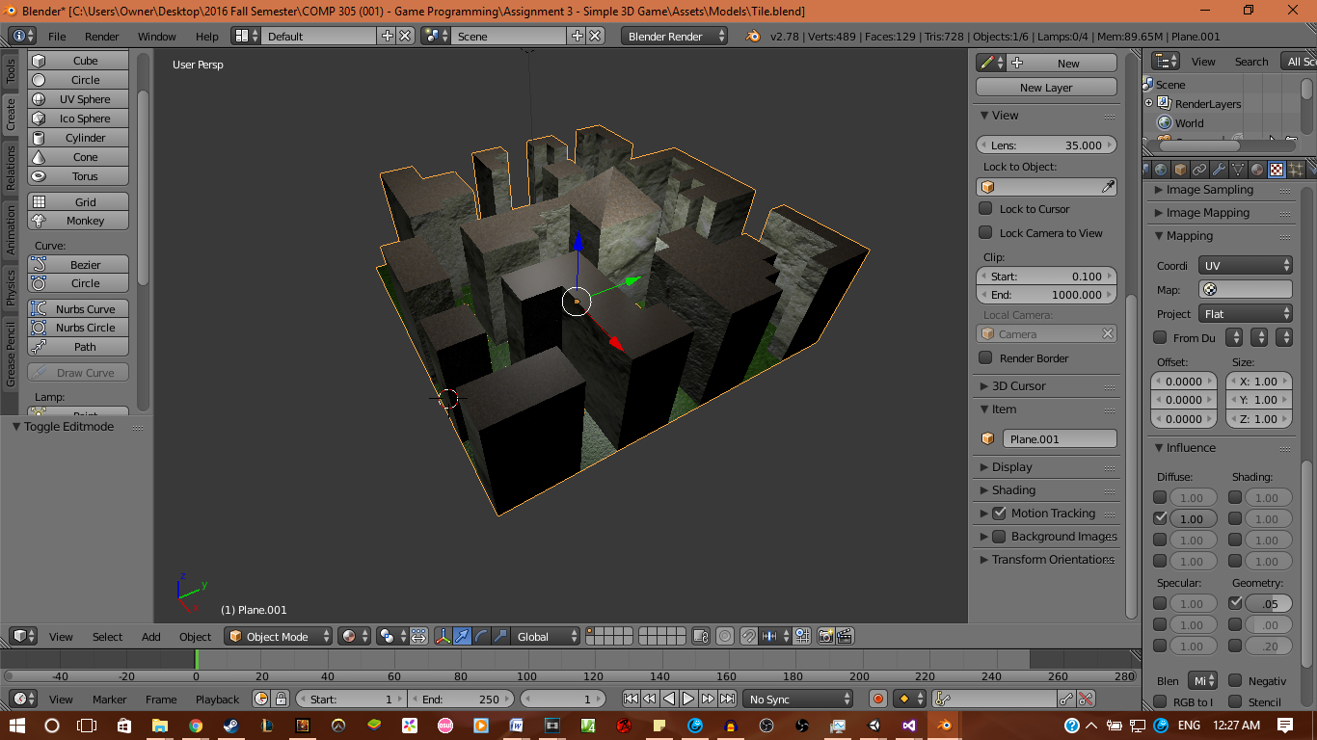

Walls:

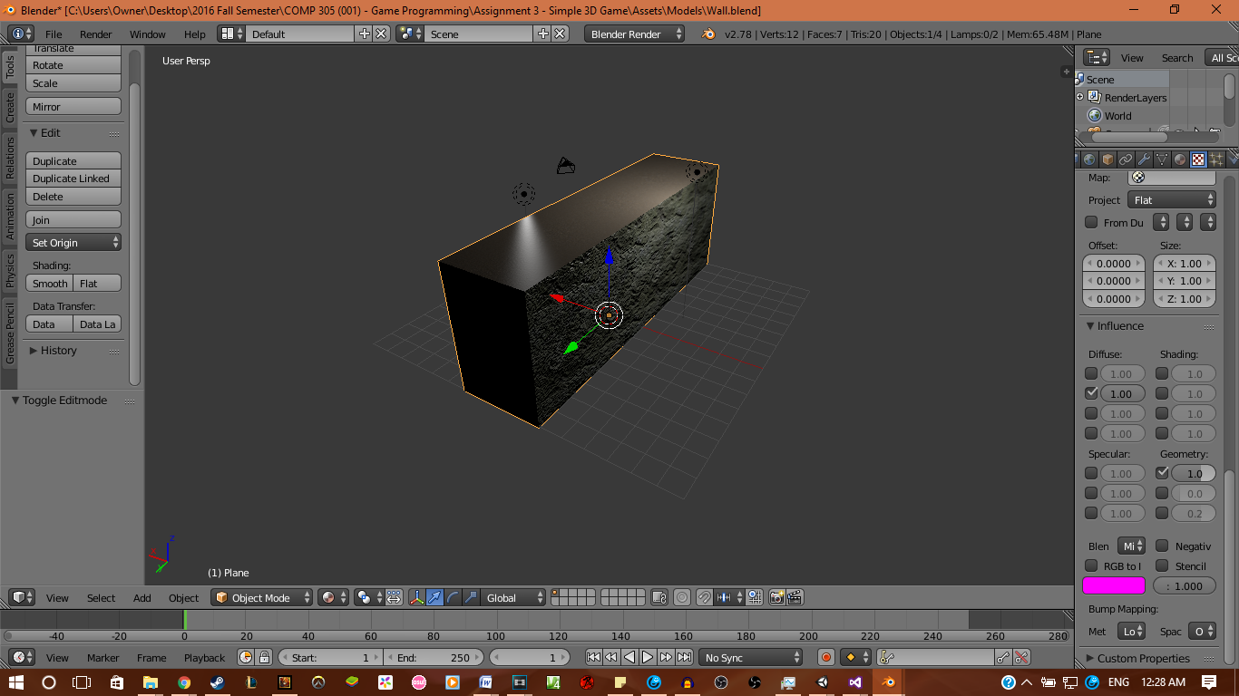

Tower (Glitched In-Game)

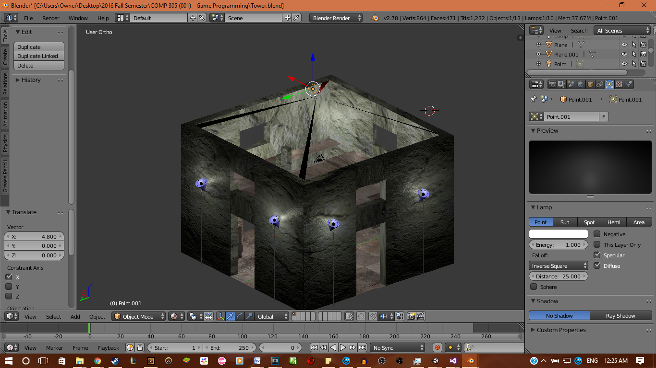

Inside of Tower

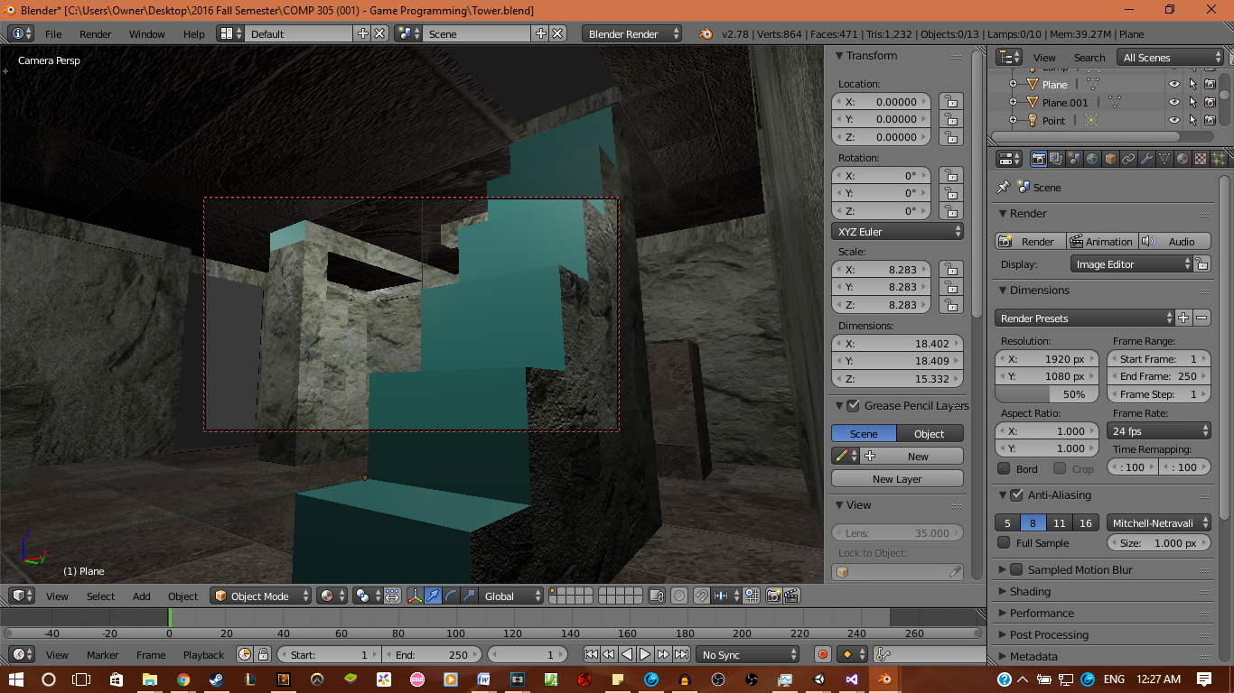

1. **Future Features**

There won’t be much for future features. It will mostly be about fixing everything so it is a working game.